SRS DOCUMENT
- ER Diagram
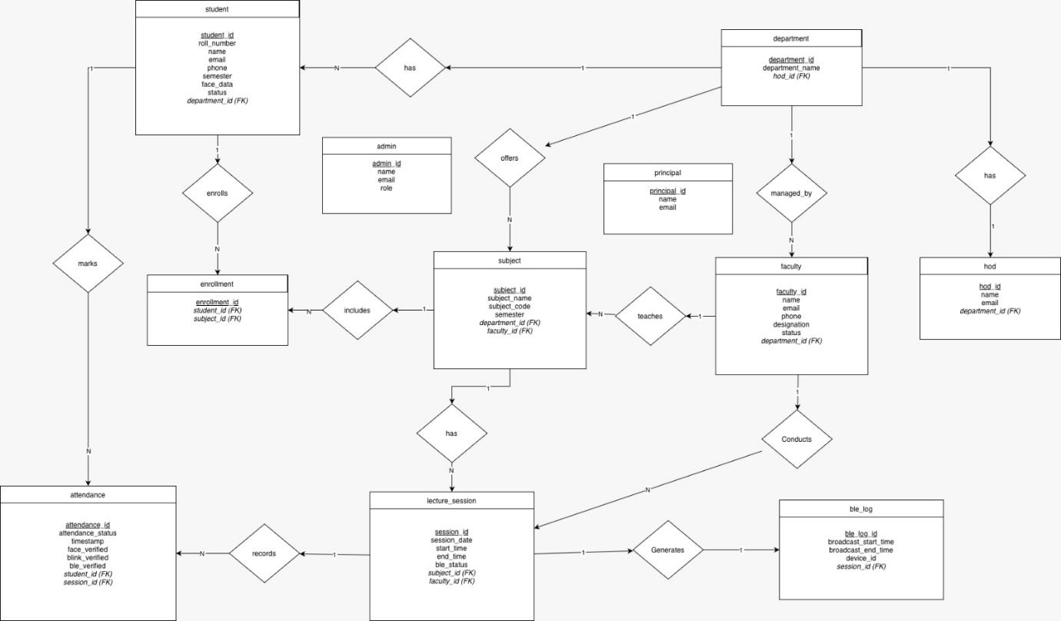

- Use case Diagram
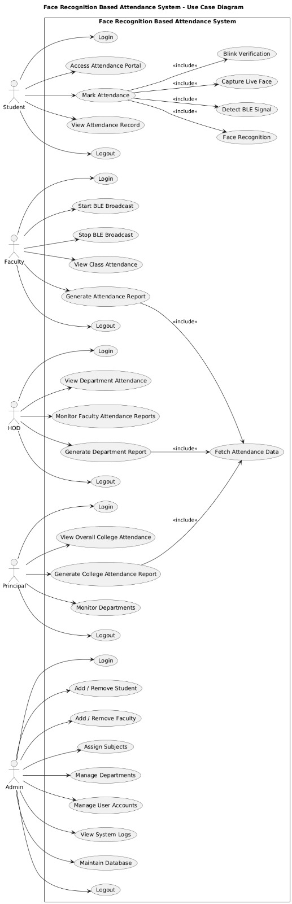
- Class Diagram
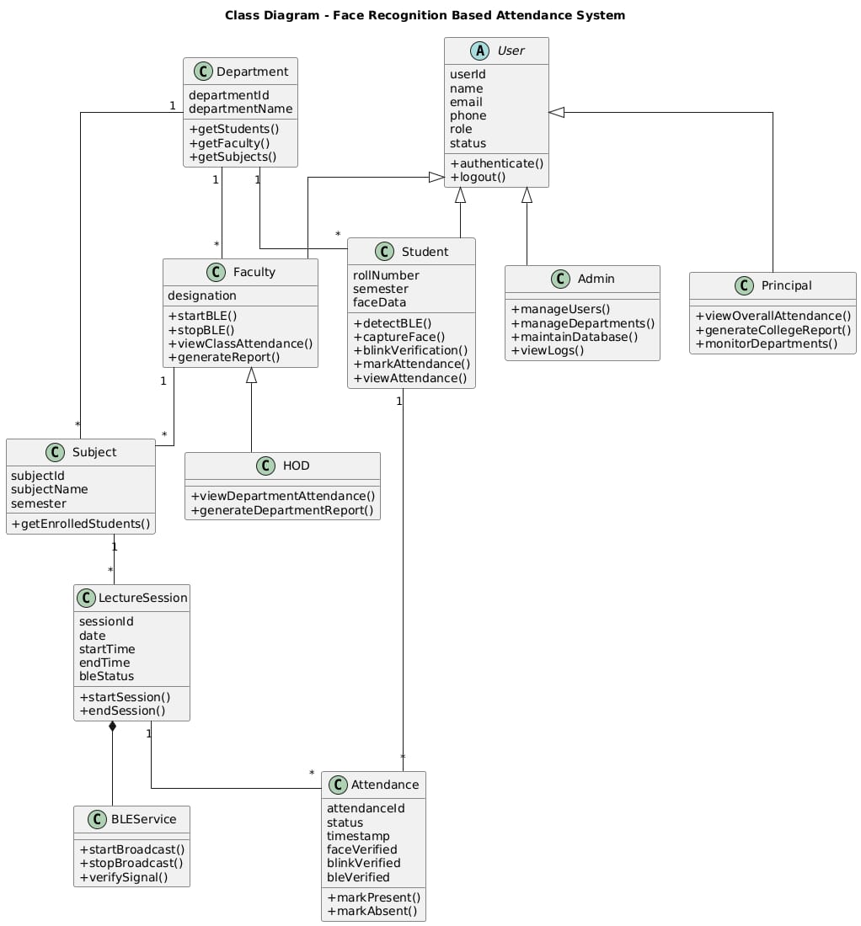

- Sequence Diagram
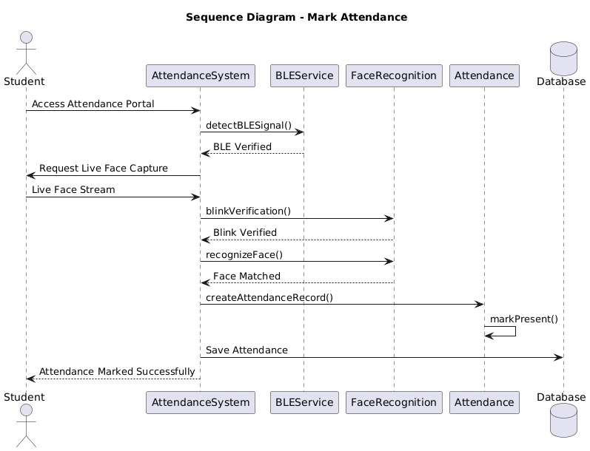

- Activity Diagram


